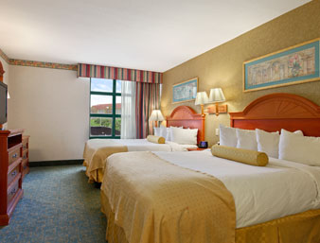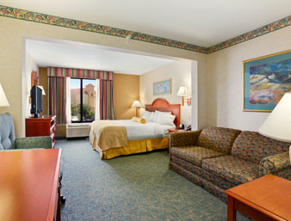

Jacksonville University Baseball Camp
Special Discounted Rates $69.00

WINGATE BY WYNDHAM-SOUTHPOINT
JACKSONVILLE, FLORIDA
.
Amenities & Services:

- Complimentary Full Hot Buffet Breakfast daily from 6:00 am – 9:30 am M-F
- Complimentary Full Hot Breakfast on Sat and Sun 7:00 am – 10:00 am
- Free shuttle service to and from YOUR venue schedule to be announced
- Late check out based on availability
- Microwave and Mid-Size Refrigerator in ALL Guest Rooms
- Oversized King and Double Queen Guest Rooms
- Complimentary High-speed Wireless Internet access in all accommodations
- In-Room Coffee Maker/Coffee, Iron/Ironing Board, Hair Dryer & Extended Cable w/HBO
- Outdoor Pool, indoor whirlpool and exercise room
- ATM on site
- On-Site coin - op Laundry Facility
- Phones with Voice Mail and Data Port
- Free Local Phone Calls and Long Distance Access
- Business Center with Complimentary High Speed Internet Access, Computer, Printer, Fax & Copier
- Free Parking
- Brand Reward Points APPLIED
- A virtual tour, map and directions are available on our website: www.jaxwingateinn.com

CALL 904.281.2600 or (cell) 904-716-9420 ASK FOR BETH RUZZO TO DISCUSS YOUR INDIVIDUAL, GROUP BLOCK OR BANQUET SPACE NEEDS

Wingate by Wyndham-Southpoint
Where serving you is our pleasure!
4681 Lenoir Avenue South Jacksonville, FL 32216
Phone: 904-281-2600 Fax: 904-281-1166
Beth.ruzzo@gmail.com


